# Report 4: Software User Manual

# 6.1. Installation Guide

## 6.1.1. Setting up environment at server side

The following software must be installed into the server machine:

### 6.1.1.1. Hardware requirement

Personal computers for developing with the minimum configuration:

* CPU Core 2 Duo 2.0GHz.
* 4GB of RAM.
* 300GB of hard disk.
* Wifi Internet (> 2Mbps).

### 6.1.1.2. Software requirement

* Web Server: Internet Information System – IIS 7.5
* Microsoft Windows 7: operating system and platform for development
* SQL Server 2008 R2: used to create and manage the database for web application

## 6.1.2. Deployment at server side

### 6.1.2.1. Prepare deployment package

Extract the deployment package to a folder on the server.

For example: C:\User\DANGTHSE60841\Desktop\OMCS

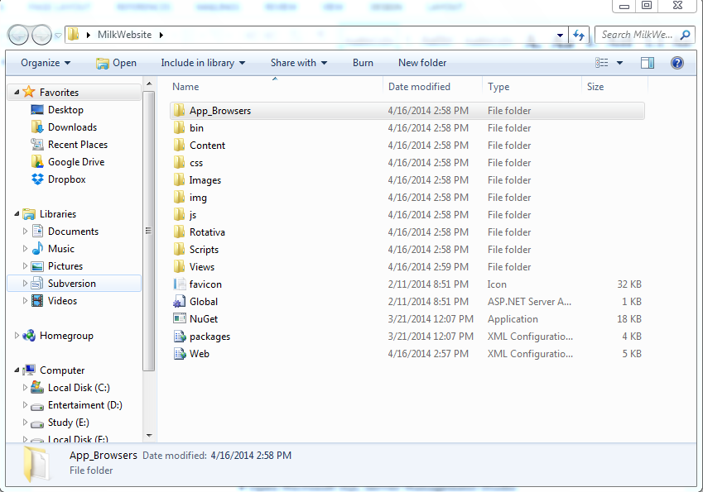

**Figure 1: Prepare deployment package**

### 6.1.2.2. Deploy database

# 6.2. User Guide

## 6.2.1. Login

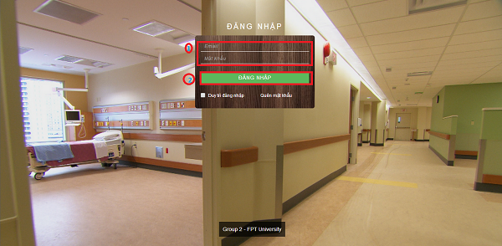

**Figure 12: Login Page**

|  |  |
| --- | --- |
| **Step** | **Description** |
| 1 | Fill Email and Password  (Sample admin account:  Email: admin@ymail.com  Password: 123456) |
| 2 | Click on “Đăng Nhập” button to login. |

**Table 1: Login Step**

## 6.2.2. Patient – User Info

### 6.2.2.1. Change Profile Image

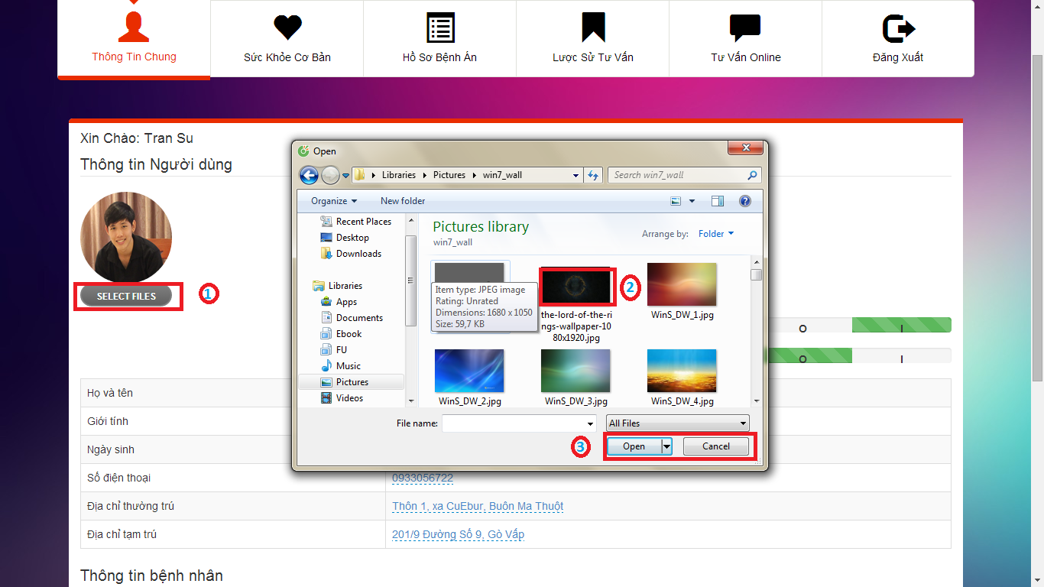

**Figure 13: Change Profile Image Windows**

|  |  |
| --- | --- |
| **Step** | **Description** |
| 1 | Click on “SELECT FILES” button to open windows explorer. |
| 2 | Choose image to upload. |
| 3 | Click on “Open” button to upload the image.  Click on “Cancel” button to close the windows |

**Table 2: Change Profile Image Step**

### 6.2.2.2. Edit Patient Info

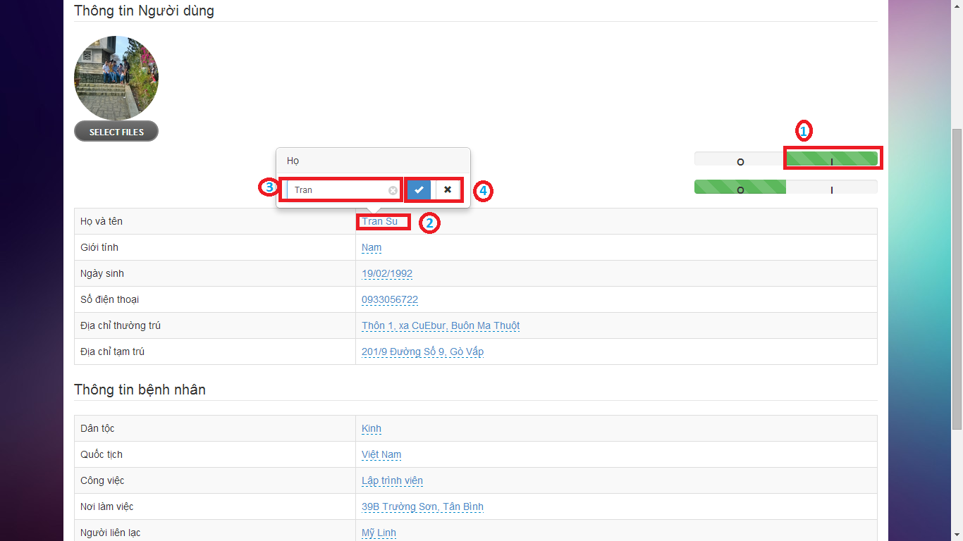

**Figure 14: Edit Patient Info**

|  |  |
| --- | --- |
| **Step** | **Description** |
| 1 | Click on “I” button to activate “Edit Patient Info” function. |
| 2 | Click on field that user wants to edit |
| 3 | Fill the text-box/select-box |
| 4 | Click on “✓” button to save the change.  Click on “×” button to cancel. |

**Table 3: Edit Patient Info Step**

## 6.2.3. Patient – User Health Record

### 6.2.3.1. Edit Personal Health Record

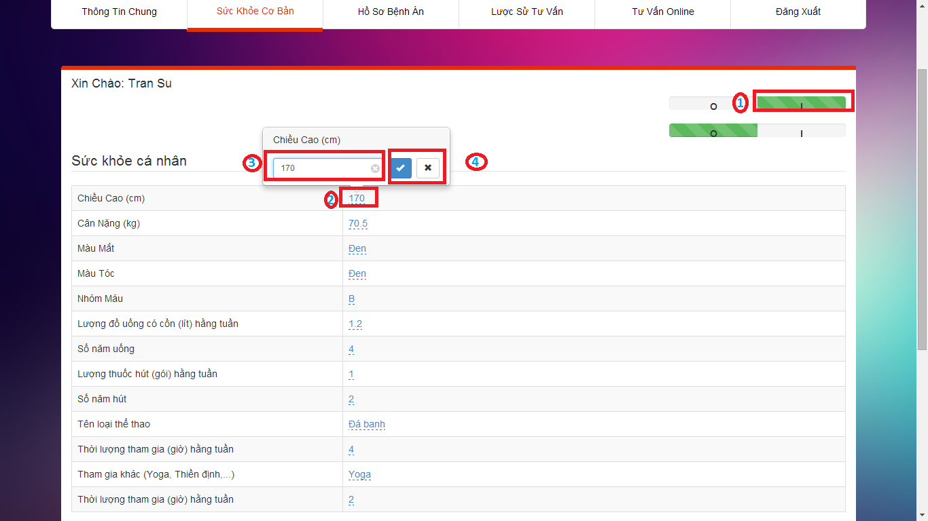

**Figure 15: Edit Personal Health Record**

|  |  |
| --- | --- |
| **Step** | **Description** |
| 1 | Click on “I” button to activate “Edit Personal Health Record” function. |
| 2 | Click on field that user wants to edit |
| 3 | Fill the text-box/select-box |
| 4 | Click on “✓” button to save the change.  Click on “×” button to cancel. |

**Table 4: Edit Personal Health Record Step**

### 6.2.3.2. View Patient Sample

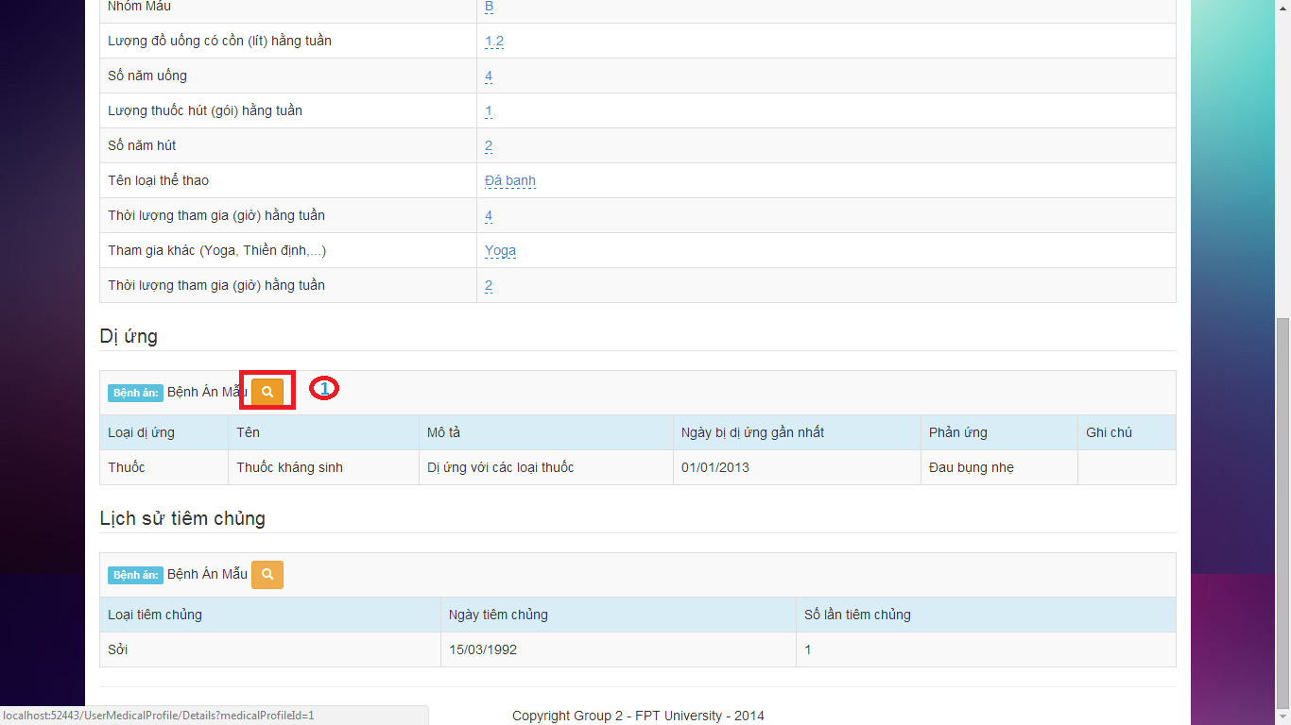

**Figure 16: View Patient Sample**

|  |  |
| --- | --- |
| **Step** | **Description** |
| 1 | Click on “Xem mẫu bệnh án” button to view the patient sample. |

**Table 5: View Patient Sample Step**

## 6.2.4. Patient - View Medical Profile Sample

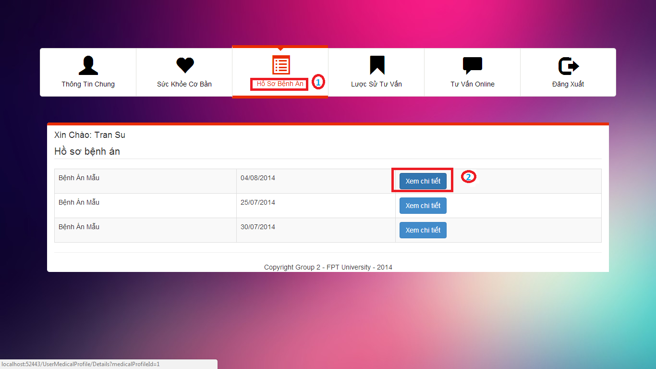

**Figure 17: User Medical Profile Page**

|  |  |
| --- | --- |
| **Step** | **Description** |
| 1 | Click on “Hồ sơ bệnh án” link to go to “Hồ sơ bệnh án” page. |
| 2 | Click on “Xem chi tiết” button on “Hồ sơ bệnh án” page. |

**Table 6: View Medical Profile Sample Step**

## 6.2.5. Patient – View Consult History

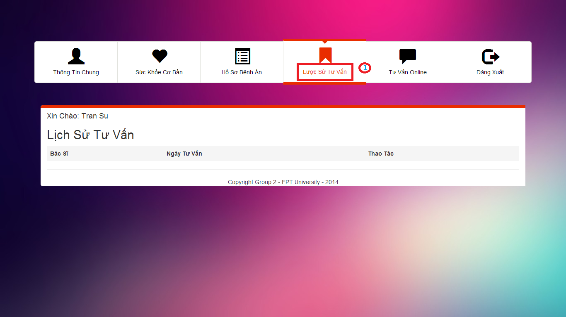

**Figure 18: View Consult History Page**

|  |  |
| --- | --- |
| **Step** | **Description** |
| 1 | Click on “Lược sử tư vấn” link to view the consult history. |

**Table 7: View Consult History Step**

## 6.2.6. Patient – Consult Online

### 6.2.6.1. Chatting

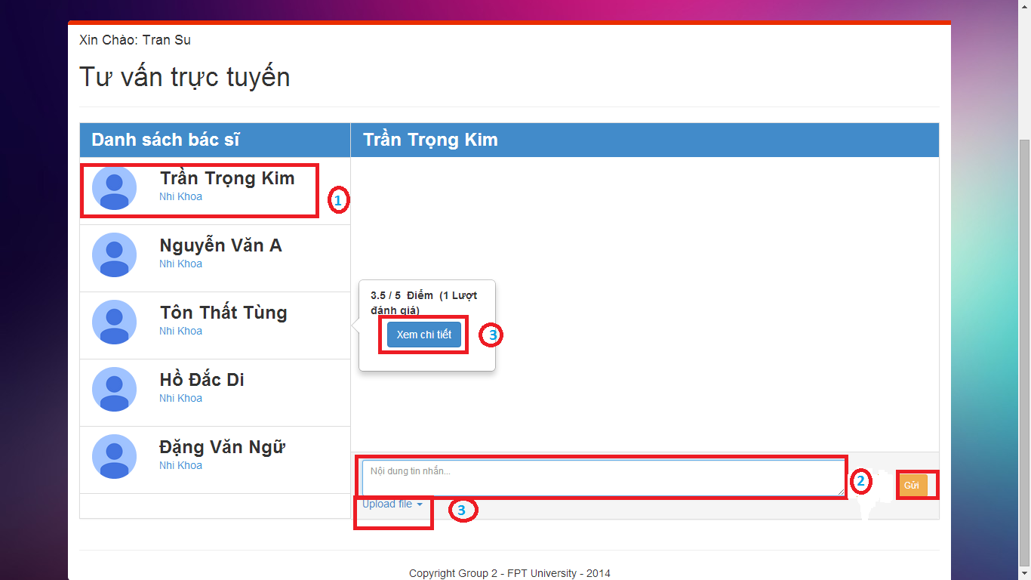

**Figure 19: Consult Online Page – Chatting**

|  |  |
| --- | --- |
| **Step** | **Description** |
| 1 | Click on “Doctor name” on doctor list to choose the doctor that patient wants to chat. |
| 2 | Fill the text-area. |
| 3 | Click on “Gửi” button to send the message.  Click on “Upload file” button to upload file.  Click on “Xem chi tiết” to view details of doctor |

**Table 8: Chatting Step**

### 6.2.6.2. View Doctor Details

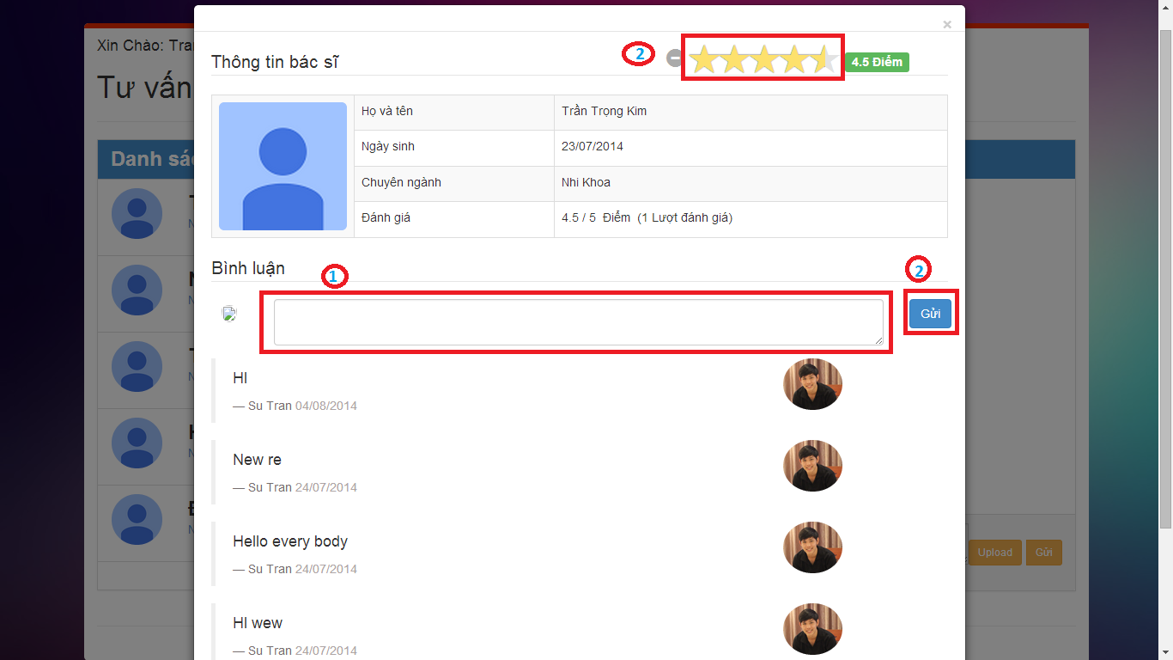

**Figure 20: View Doctor Details Page**

|  |  |
| --- | --- |
| **Step** | **Description** |
| 1 | Fill the text-area. |
| 2 | Click on “Gửi” button to send the comment.  Click on “Đánh giá” to rate for the doctor. |

**Table 9: View Doctor Details Step**

## 6.2.7. Doctor - Mange Patient

### 6.2.7.1. Create New Patient

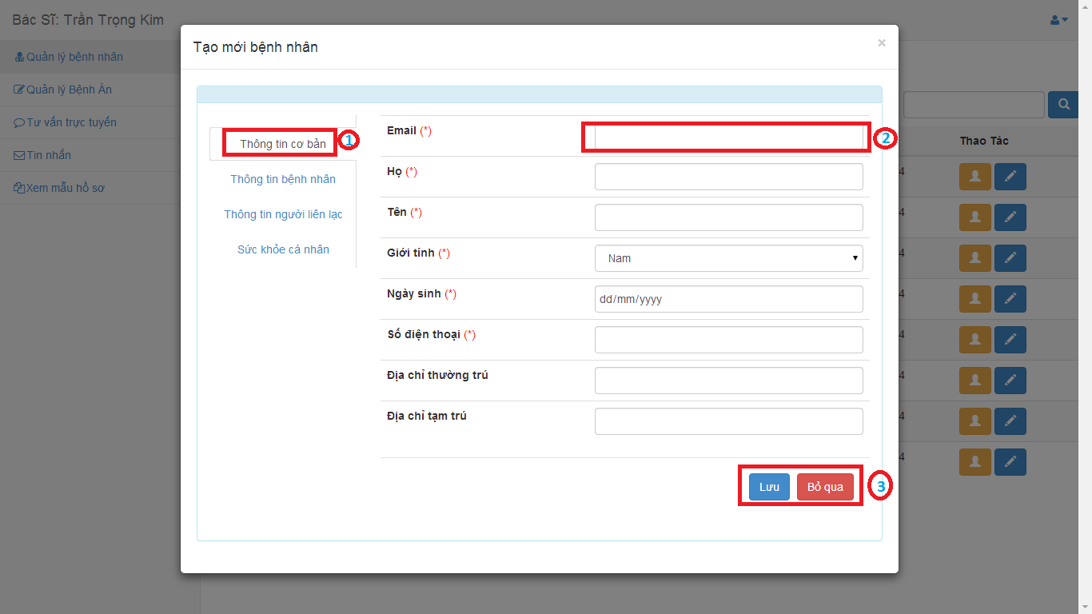

**Figure 21: Create New Patient Page**

|  |  |
| --- | --- |
| **Step** | **Description** |
| 1 | Choose the tab. |
| 2 | Input the value. |
| 3 | Click on “Lưu” button to create new patient.  Click on “Bỏ qua” button to cancel. |

**Table 10: Create New Patient Step**

### 6.2.7.2. View Patient Details

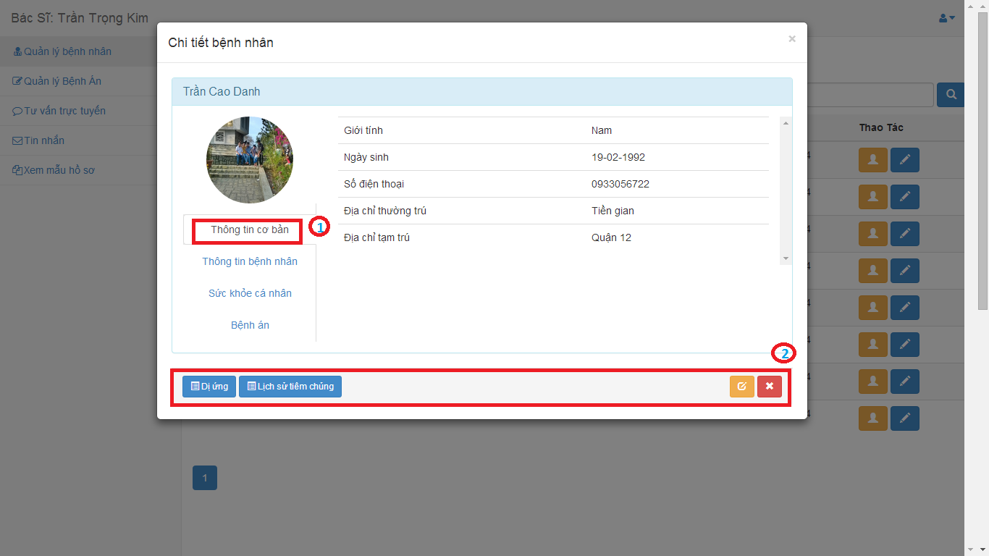

**Figure 22: View Patient Details Page**

|  |  |
| --- | --- |
| **Step** | **Description** |
| 1 | Choose the tab to view |
| 2 | Click on “Dị ứng” button to view allergy history.  Click on “Lịch sử tiêm chủng” button to view vaccination history.  Click on “Cập nhật” button to edit patient details.  Click on “Bỏ qua” button to close. |

**Table 11: View Patient Details Step**

### 6.2.7.3. Edit Patient Details

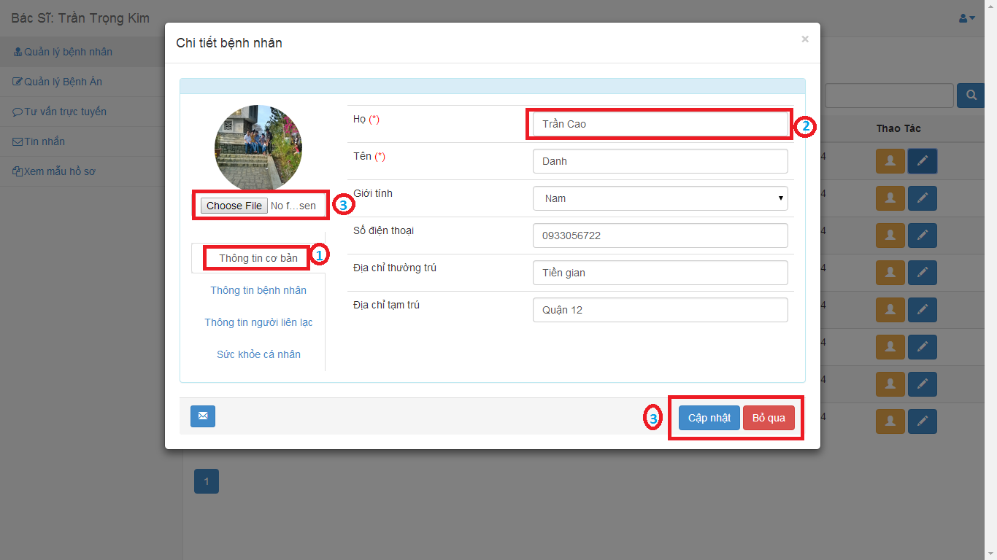

**Figure 22: Edit Patient Details Page**

|  |  |
| --- | --- |
| **Step** | **Description** |
| 1 | Choose the tab to view |
| 2 | Input the value |
| 3 | Click on “Choose file” button to upload new profile image.  Click on “Cập nhật” button to save.  Click on “Bỏ qua” button to cancel. |

**Table 12: Edit Patient Details Step**

## 6.2.8. Doctor – Consult Online

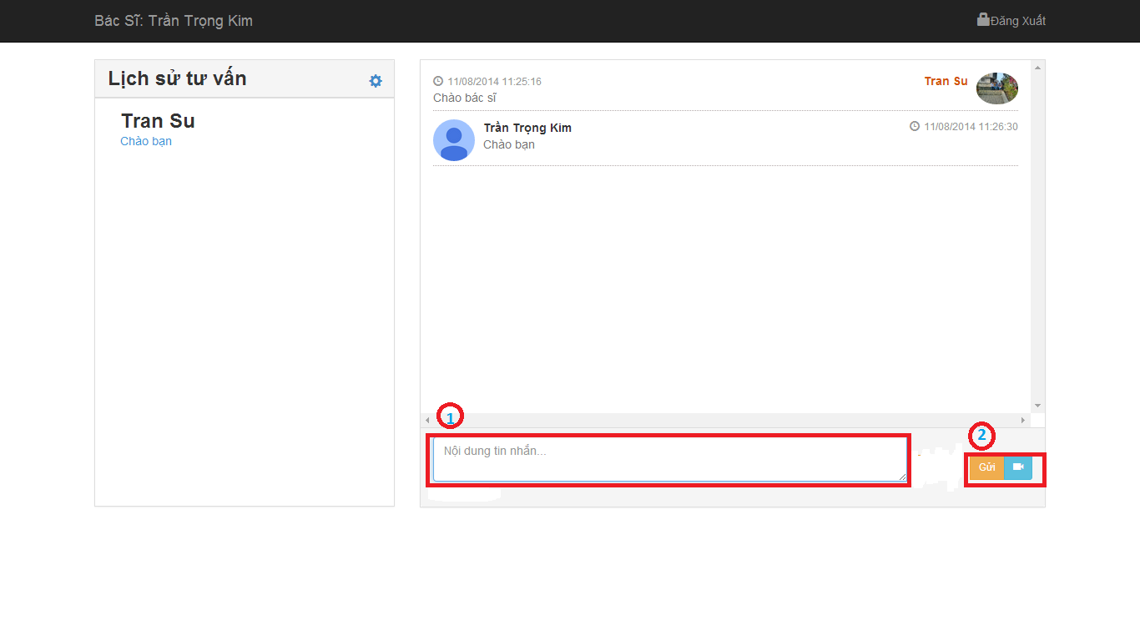

**Figure 28: Consulting Online Page**

|  |  |
| --- | --- |
| **Step** | **Description** |
| 1 | Fill the text-box. |
| 2 | Click on “Gửi” button to send message.  Click on “Webcam” button to request watching patient’s webcam. |

**Table 16: Consult Online Step**

## 6.2.9. Doctor – Message

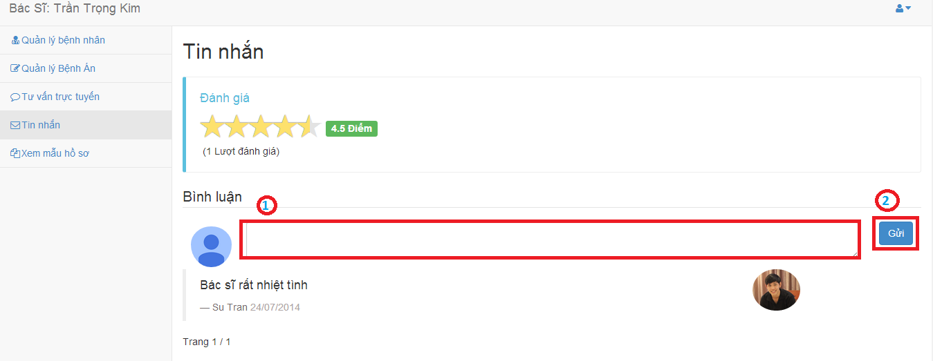

**Figure 28: Message Page**

|  |  |
| --- | --- |
| **Step** | **Description** |
| 1 | Fill the text-box. |
| 2 | Click on “Gửi” button to send comment. |

**Table 18: Comment Step**

## 6.2.10. Admin – Manage Hospital Information

### 6.2.10.1 View/Edit hospital information

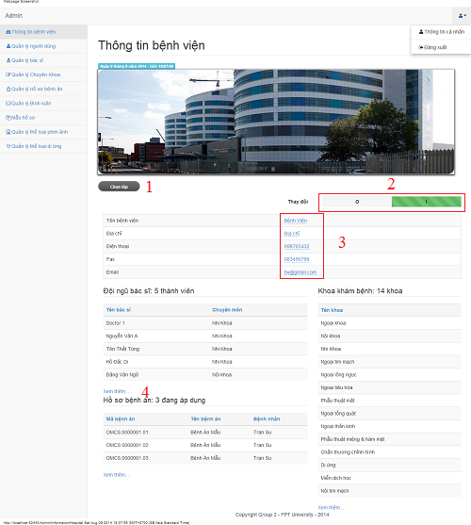

|  |  |
| --- | --- |
| **Step** | **Description** |
| 1 | Select file to change hospital’s logo |
| 2 | Click on “I” to edit hospital information or click on “O” to view hospital information |
| 3 | Fill hospital information to edit |
| 4 | Click on “Xem thêm….” to forward to other page |

## 6.2.11. Admin – Manage Users

### 6.2.11.1. View user list

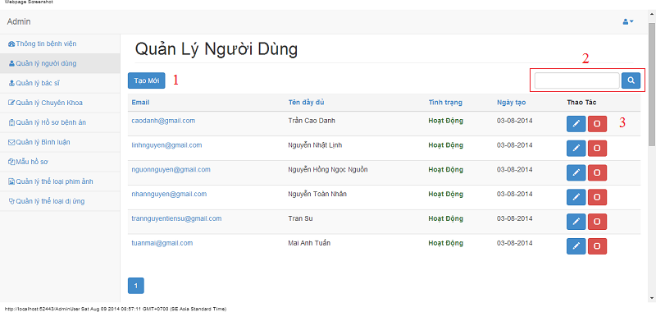

|  |  |
| --- | --- |
| **Step** | **Description** |
| 1 | Fill user’s name/email and click search button to find user |
| 2 | Click “Tạo mới” button to create a new user |
| 3 | Click edit button to edit user’s details  Click check button to lock or unlock user |

### 6.2.11.2. Create user

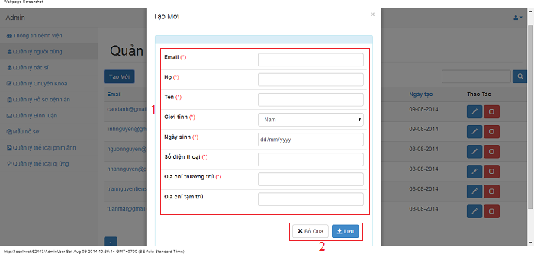

|  |  |
| --- | --- |
| **Step** | **Description** |
| 1 | Fill all user detail |
| 2 | Click on “Lưu” button to save user  Click on “Bỏ qua” dismiss modal |

### 6.2.11.3. Edit user

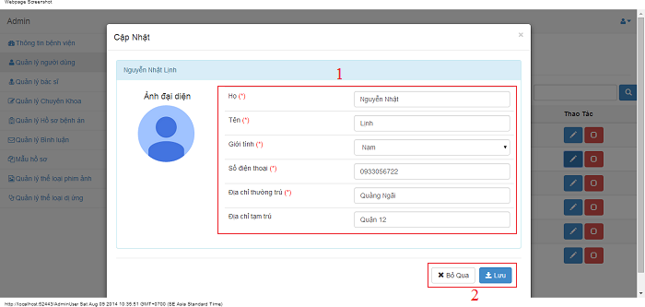

|  |  |
| --- | --- |
| **Step** | **Description** |
| 1 | Fill all user detail to edit |
| 2 | Click on “Lưu” button to save user  Click on “Bỏ qua” dismiss modal |

## 6.2.12. Admin – Manage Doctors

### 6.2.12.1. View doctor list

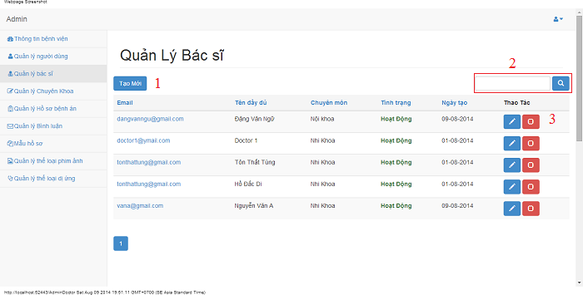

|  |  |
| --- | --- |
| **Step** | **Description** |
| 1 | Fill doctor’s name/email and click on search button to find user |
| 2 | Click on “Tạo mới” button to create a new doctor |
| 3 | Click on edit button to edit doctor’s details  Click on check button to lock or unlock doctor |

### 6.2.12.2. Create doctor

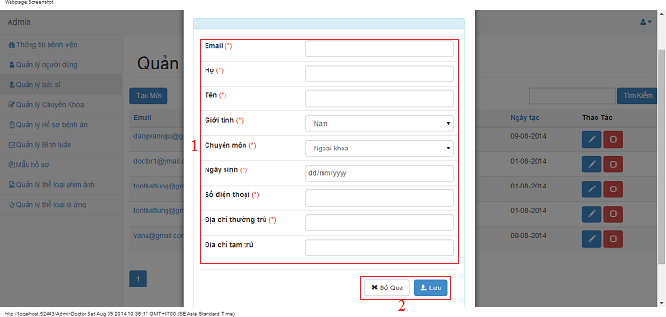

|  |  |
| --- | --- |
| **Step** | **Description** |
| 1 | Fill all doctor detail |
| 2 | Click on “Lưu” button to save doctor  Click on “Bỏ qua” dismiss modal |

### 6.2.12.3. Edit doctor

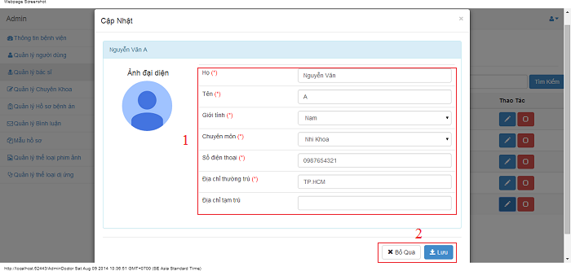

|  |  |
| --- | --- |
| **Step** | **Description** |
| 1 | Fill all doctor detail to edit |
| 2 | Click on “Lưu” button to save doctor  Click on “Bỏ qua” dismiss modal |

## 6.2.12. Admin – Manage Medical Profiles

### 6.2.12.1. View medical profile list

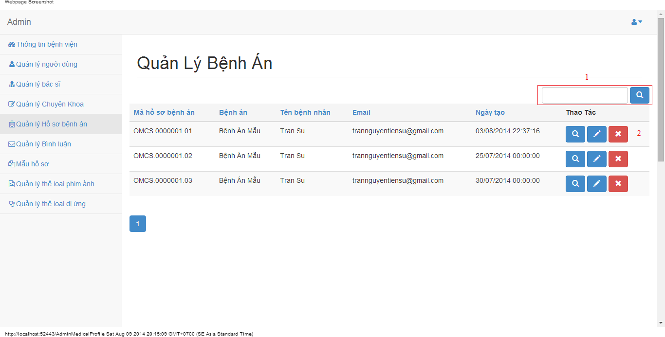

|  |  |
| --- | --- |
| **Step** | **Description** |
| 1 | Fill medial profile name/key/patient’s name and click on search button to find medical profile |
| 2 | Click on view button to view medical profile’s details  Click on edit button to edit medical profile’s details  Click on delete button to delete medical profile’s details |

### 6.2.12.2 View details a medical profile

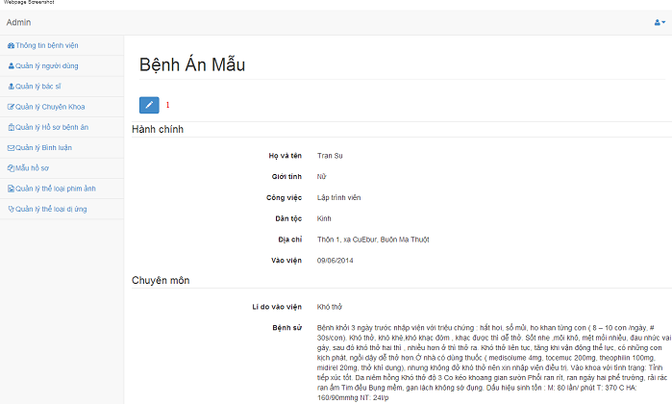

|  |  |
| --- | --- |
| **Step** | **Description** |
| 1 | Click on edit button to forward to edit medical profile |

### 6.2.12.3. Update medical profile

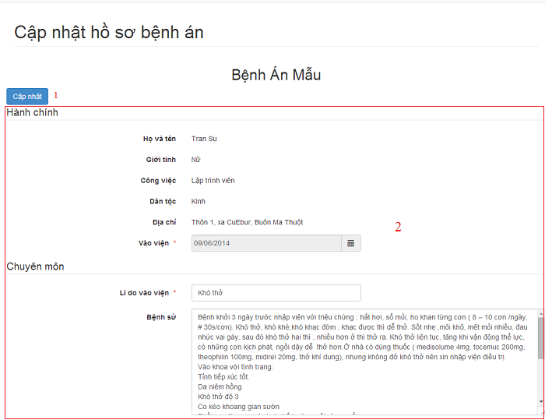

|  |  |
| --- | --- |
| **Step** | **Description** |
| 1 | Click on “Cập nhật” button to save doctor |
| 2 | Fill all medical profile detail to edit |

## 6.2.13. Admin – Manage Specialty Fields

### 6.2.13.1. View specialty fields

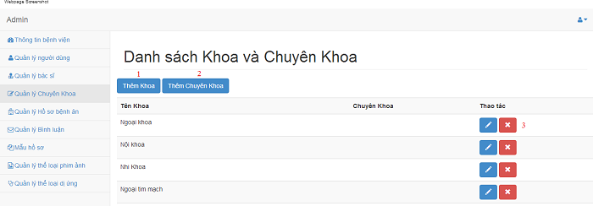

|  |  |
| --- | --- |
| **Step** | **Description** |
| 1 | Click on “Thêm Khoa” button to create a parent specialty |
| 2 | Click on “Thêm Chuyên Khoa” button to create a specialty |
| 3 | Click on edit button to edit specialty’s details  Click on remove button to delete a specialty field |

### 6.2.13.2. Create parent specialty field

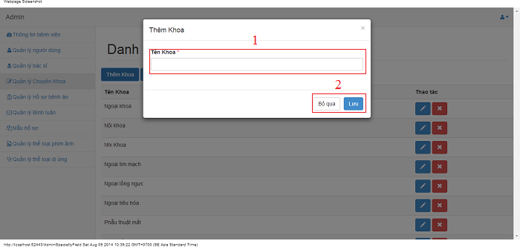

|  |  |
| --- | --- |
| **Step** | **Description** |
| 1 | Fill all parent specialty detail |
| 2 | Click on “Lưu” button to save parent specialty  Click on “Bỏ qua” dismiss modal |

### 6.2.13.3. Create specialty field

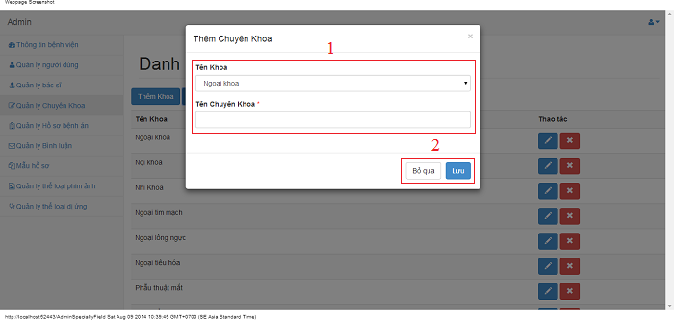

|  |  |
| --- | --- |
| **Step** | **Description** |
| 1 | Fill all specialty detail |
| 2 | Click on “Lưu” button to save specialty  Click on “Bỏ qua” dismiss modal |

### 6.2.13.4. Edit parent specialty field

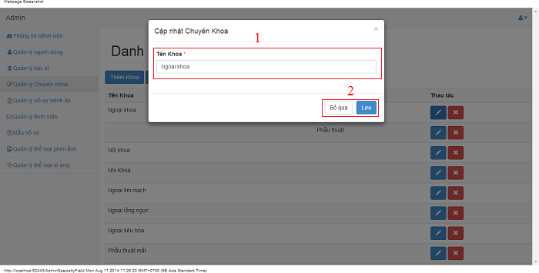

|  |  |
| --- | --- |
| **Step** | **Description** |
| 1 | Fill all parent specialty detail to edit |
| 2 | Click on “Lưu” button to save parent specialty  Click on “Bỏ qua” dismiss modal |

### 6.2.13.5. Edit specialty field

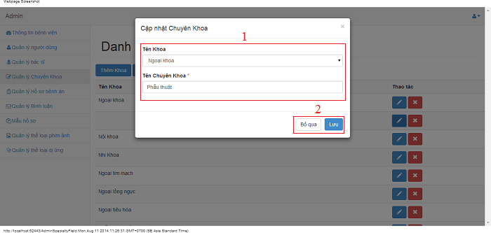

|  |  |
| --- | --- |
| **Step** | **Description** |
| 1 | Fill all specialty detail to edit |
| 2 | Click on “Lưu” button to save specialty  Click on “Bỏ qua” dismiss modal |

## 6.2.14. Admin – Manage Medical Profile Templates

### 6.2.14.1. View medical profile template list

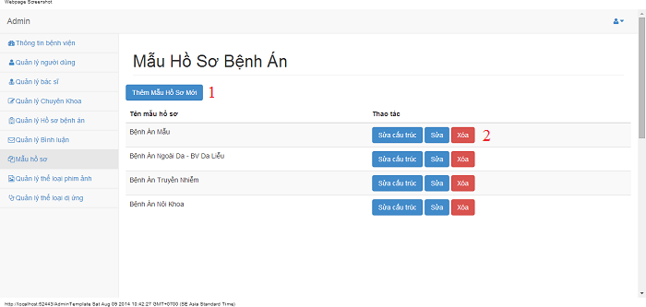

|  |  |
| --- | --- |
| **Step** | **Description** |
| 1 | Click on “Thêm Mẫu Hồ Sơ Mới” button to create a medical profile template |
| 2 | Click on “Sửa cấu trúc” button to edit medical profile template  Click on “Sửa” button to edit medical profile template name  Click on “Xóa” button to delete a medical profile template |

### 6.2.14.2. Create medical profile template

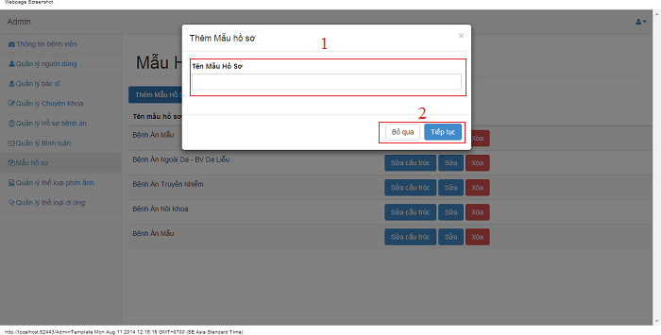

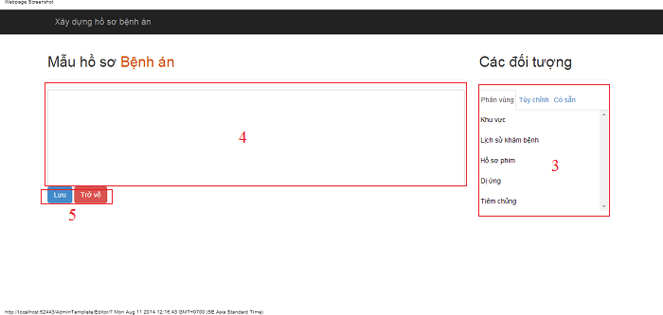

|  |  |
| --- | --- |
| **Step** | **Description** |
| 1 | Fill medical profile template name |
| 2 | Click on “Tiếp tục” button to create medical profile template  Click on “Bỏ qua” button to dismiss modal |
| 3 | Step 2 click on “Tiếp tục” button  Drag value on 3 tabs: “Phân vùng”, “Tùy chỉnh” and “Có sẵn” in step 4 |
| 4 | Admin drag value on tab to this |
| 5 | Click on “Lưu” button to save medical profile template  Click on “Trở về” button to redirect previous page. |

### 6.2.14.3. Update medical profile template name

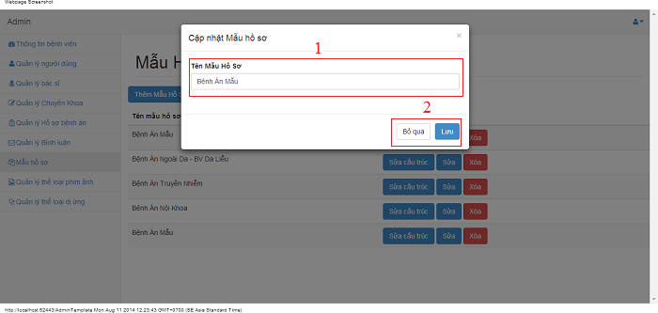

|  |  |
| --- | --- |
| **Step** | **Description** |
| 1 | Fill medical profile template name |
| 2 | Click on “Tiếp tục” button to edit medical profile template name  Click on “Bỏ qua” button to dismiss modal |

### 6.2.14.4. Update medical profile template

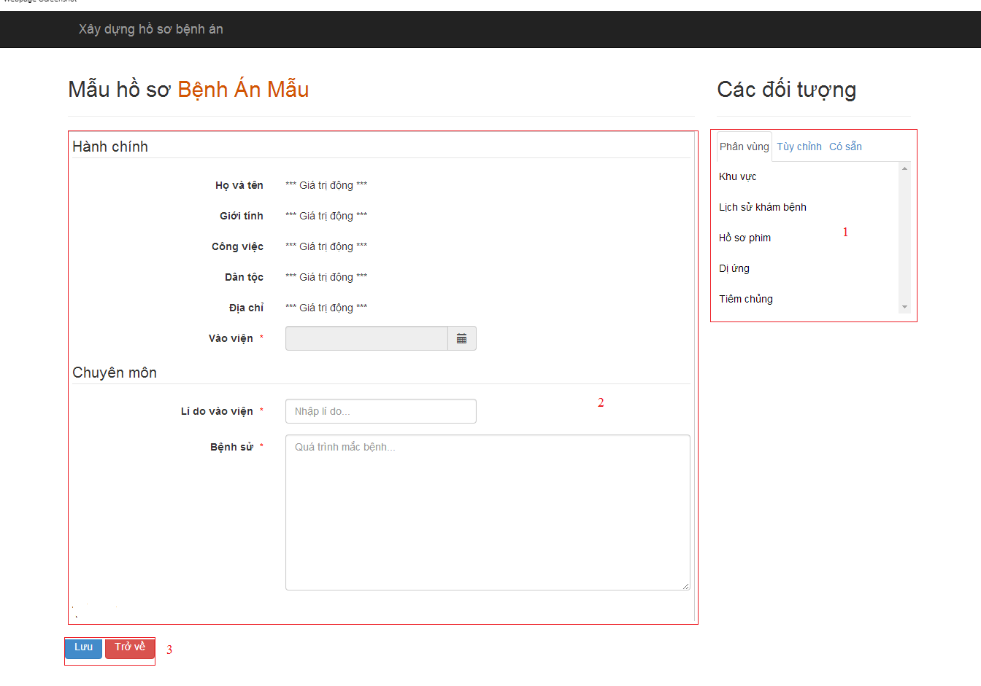

|  |  |
| --- | --- |
| **Step** | **Description** |
| 1 | Drag value on 3 tabs: “Phân vùng”, “Tùy chỉnh” and “Có sẵn” in step 2 |
| 2 | Admin drag in or out value on tab to this |
| 3 | Click on “Lưu” button to save medical profile template  Click on “Trở về” button to redirect previous page. |

## 6.2.15. Admin – Manage Personal Information

### 6.2.15.1 View/Edit personal information

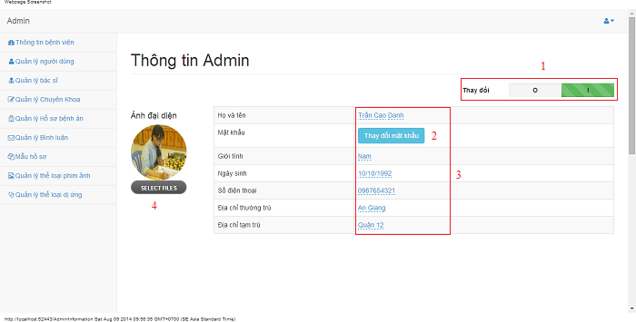

|  |  |
| --- | --- |
| **Step** | **Description** |
| 1 | Click on “I” to edit personal information or click on “O” to view personal information |
| 2 | Click on “Thay đổi mật khẩu” button to edit password |
| 3 | Fill personal information to edit |
| 4 | Select file to change profile picture |